Module 10 JSON Persistence and View Model Tests
Replace the in-memory BOM service with a JSON-backed implementation while keeping the same view model and editor workflow. Add tests that prove saved items reload and that Cancel or a declined confirmation leaves the collection alone. A visible error message tells the user when loading or saving fails.

Starting point and learning goals
Start from the completed Module 9 branch. Create a new feature branch before editing. Build the Windows target at each checkpoint.
Learning goals: Use Task-returning service operations for file work; Separate persisted data from UI behavior; Preserve the visible collection when storage fails; Connect page lifecycle to view model loading; Replace UI interactions with a fake.

Step 1 Make storage asynchronous
Concept. Use Task-returning service operations for file work
Do. Change IBomService to LoadAsync, AddItemAsync, ReplaceItemAsync, and RemoveItemAsync. Update the in-memory implementation first so the current app and tests still have a simple substitute.
Check. The project builds after the interface and callers are updated.

Step 2 Write a JSON service
Concept. Separate persisted data from UI behavior
Do. Add JsonBomService with a file path constructor. Load the JSON list into its observable collection. Save a temporary file and move it over the previous file after successful serialization. Serialize operations with SemaphoreSlim.
Check. A new service instance can reload what a previous instance saved.
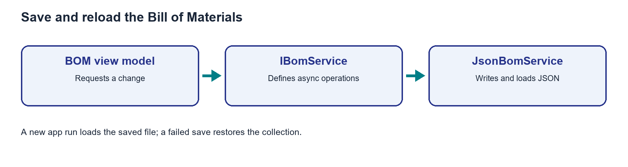
Figure. The view model uses the service contract; the JSON implementation saves and reloads the collection.

Step 3 Handle save failures
Concept. Preserve the visible collection when storage fails
Do. For Add, Edit, and Delete, change the observable collection, attempt to save, and undo the change if the save throws. Let the view model show a concise error.
Check. A failed save does not leave an unsaved row on screen.

Step 4 Load when the page appears
Concept. Connect page lifecycle to view model loading
Do. Register JsonBomService as the singleton IBomService using FileSystem.AppDataDirectory. Invoke the generated LoadCommand from the BOM page OnAppearing method. Bind ErrorText above the collection.
Check. A new app run restores the saved list, including edits and deletions.
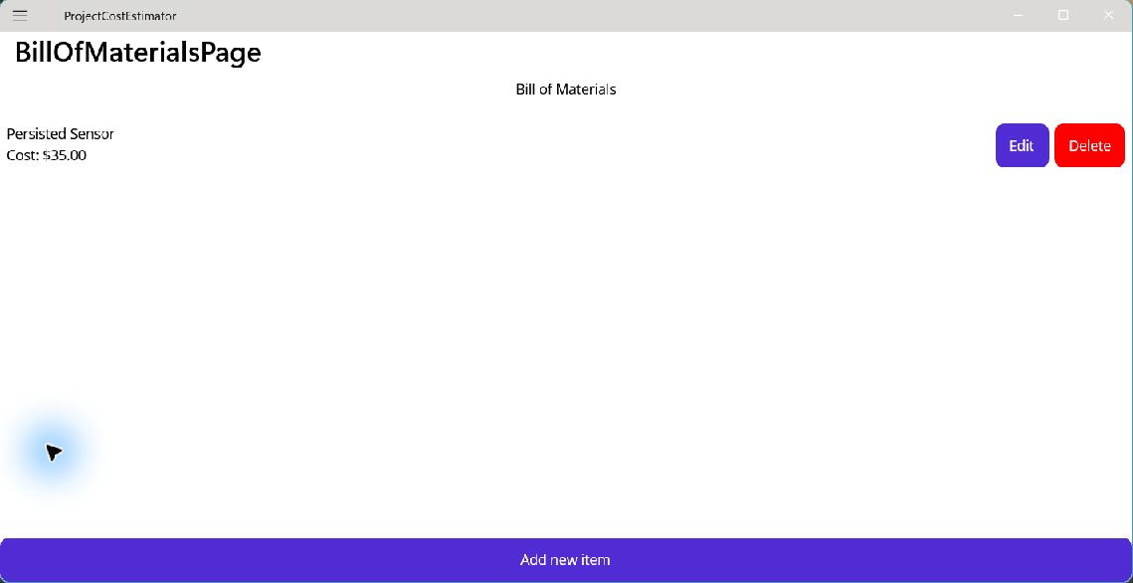
Figure. The new item appears after it has been saved.
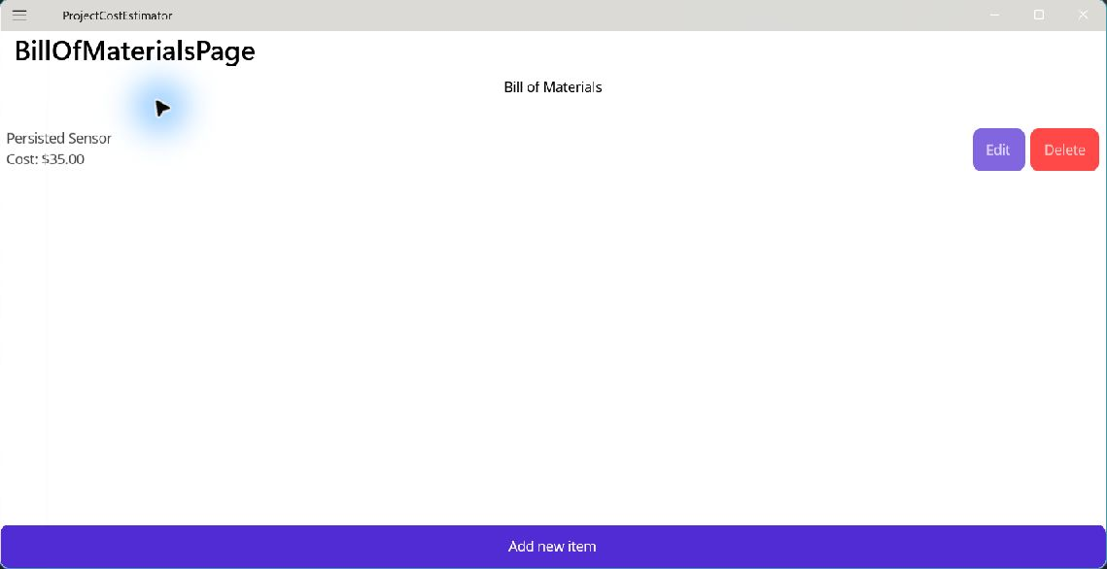
Figure. The same item appears after closing and reopening the application.

Step 5 Test without a window
Concept. Replace UI interactions with a fake
Do. Create an xUnit test project. Test JSON save, reload, replace, and remove. Use a fake IBomInteractionService to test Cancel, declined Delete, and confirmed Delete through the generated commands.
Check. All tests pass, and the Windows MAUI build has zero warnings and errors.

Further reading
https://learn.microsoft.com/dotnet/maui/platform-integration/storage/file-system-helpers
https://learn.microsoft.com/dotnet/standard/serialization/system-text-json/how-to
https://learn.microsoft.com/dotnet/core/testing/unit-testing-csharp-with-xunit

Full source checkpoints
The files below show the completed module. Read them after following the small steps above, or use them to compare your result.

Services/IBomService.cs
using System.Collections.ObjectModel;
using ProjectCostEstimator.Models;

namespace ProjectCostEstimator.Services;

public interface IBomService
{
ObservableCollection<MaterialItem> Items { get; }

Task LoadAsync();

Task AddItemAsync(MaterialItem item);

Task ReplaceItemAsync(MaterialItem original, MaterialItem replacement);

Task RemoveItemAsync(MaterialItem item);
}

Services/InMemoryBomService.cs
using System.Collections.ObjectModel;
using ProjectCostEstimator.Models;

namespace ProjectCostEstimator.Services;

// Useful for exercises and tests; the app registers JsonBomService in Module 10.
public sealed class InMemoryBomService : IBomService
{
public ObservableCollection<MaterialItem> Items { get; } = new();

public Task LoadAsync() => Task.CompletedTask;

public Task AddItemAsync(MaterialItem item)
{
Items.Add(item);
return Task.CompletedTask;
}

public Task ReplaceItemAsync(MaterialItem original, MaterialItem replacement)
{
int index = Items.IndexOf(original);
if (index >= 0)
Items[index] = replacement;
return Task.CompletedTask;
}

public Task RemoveItemAsync(MaterialItem item)
{
Items.Remove(item);
return Task.CompletedTask;
}
}

Services/JsonBomService.cs
using System.Collections.ObjectModel;
using System.Text.Json;
using ProjectCostEstimator.Models;

namespace ProjectCostEstimator.Services;

public sealed class JsonBomService(string filePath) : IBomService
{
private readonly SemaphoreSlim gate = new(1, 1);
private readonly JsonSerializerOptions options = new() { WriteIndented = true };

public ObservableCollection<MaterialItem> Items { get; } = new();

public async Task LoadAsync()
{
await gate.WaitAsync();
try
{
if (!File.Exists(filePath))
return;

await using var stream = File.OpenRead(filePath);
var loaded = await JsonSerializer.DeserializeAsync<List<MaterialItem>>(stream, options)
?? throw new JsonException("The BOM file does not contain a list.");

Items.Clear();
foreach (var item in loaded)
Items.Add(item);
}
finally
{
gate.Release();
}
}

public async Task AddItemAsync(MaterialItem item)
{
await gate.WaitAsync();
try
{
Items.Add(item);
try { await SaveAsync(); }
catch { Items.Remove(item); throw; }
}
finally { gate.Release(); }
}

public async Task ReplaceItemAsync(MaterialItem original, MaterialItem replacement)
{
await gate.WaitAsync();
try
{
int index = Items.IndexOf(original);
if (index < 0) return;
Items[index] = replacement;
try { await SaveAsync(); }
catch { Items[index] = original; throw; }
}
finally { gate.Release(); }
}

public async Task RemoveItemAsync(MaterialItem item)
{
await gate.WaitAsync();
try
{
int index = Items.IndexOf(item);
if (index < 0) return;
Items.RemoveAt(index);
try { await SaveAsync(); }
catch { Items.Insert(index, item); throw; }
}
finally { gate.Release(); }
}

private async Task SaveAsync()
{
string? directory = Path.GetDirectoryName(filePath);
if (!string.IsNullOrEmpty(directory))
Directory.CreateDirectory(directory);

string temporaryPath = filePath + ".tmp";
try
{
await using (var stream = File.Create(temporaryPath))
await JsonSerializer.SerializeAsync(stream, Items.ToList(), options);
File.Move(temporaryPath, filePath, true);
}
finally
{
if (File.Exists(temporaryPath))
File.Delete(temporaryPath);
}
}
}

ViewModels/BillOfMaterialsViewModel.cs
using System.Collections.ObjectModel;
using CommunityToolkit.Mvvm.ComponentModel;
using CommunityToolkit.Mvvm.Input;
using ProjectCostEstimator.Models;
using ProjectCostEstimator.Services;

namespace ProjectCostEstimator.ViewModels;

public partial class BillOfMaterialsViewModel(
IBomService bomService,
IBomInteractionService interactions) : ObservableObject
{
public ObservableCollection<MaterialItem> Items => bomService.Items;

[ObservableProperty]
public partial string ErrorText { get; set; }

[RelayCommand]
private async Task LoadAsync()
{
try
{
await bomService.LoadAsync();
ErrorText = string.Empty;
}
catch (Exception ex) when (ex is IOException or UnauthorizedAccessException or System.Text.Json.JsonException)
{
ErrorText = $"Could not load the bill of materials: {ex.Message}";
}
}

[RelayCommand]
private async Task AddAsync()
{
MaterialItem? item = await interactions.EditItemAsync(null);
if (item is not null)
{
try { await bomService.AddItemAsync(item); ErrorText = string.Empty; }
catch (Exception ex) when (ex is IOException or UnauthorizedAccessException)
{ ErrorText = $"Could not save the item: {ex.Message}"; }
}
}

[RelayCommand]
private async Task EditAsync(MaterialItem? original)
{
if (original is null || !Items.Contains(original))
return;

MaterialItem? edited = await interactions.EditItemAsync(original);
if (edited is not null)
{
try { await bomService.ReplaceItemAsync(original, edited); ErrorText = string.Empty; }
catch (Exception ex) when (ex is IOException or UnauthorizedAccessException)
{ ErrorText = $"Could not save the edit: {ex.Message}"; }
}
}

[RelayCommand]
private async Task DeleteAsync(MaterialItem? item)
{
if (item is null || !Items.Contains(item))
return;

if (await interactions.ConfirmDeleteAsync(item))
{
try { await bomService.RemoveItemAsync(item); ErrorText = string.Empty; }
catch (Exception ex) when (ex is IOException or UnauthorizedAccessException)
{ ErrorText = $"Could not save the deletion: {ex.Message}"; }
}
}
}

Views/BillOfMaterialsPage.xaml
<?xml version="1.0" encoding="utf-8" ?>
<ContentPage xmlns="http://schemas.microsoft.com/dotnet/2021/maui"
xmlns:x="http://schemas.microsoft.com/winfx/2009/xaml"
xmlns:models="clr-namespace:ProjectCostEstimator.Models"
xmlns:viewModels="clr-namespace:ProjectCostEstimator.ViewModels"
x:Class="ProjectCostEstimator.Views.BillOfMaterialsPage"
x:Name="BomPage"
x:DataType="viewModels:BillOfMaterialsViewModel"
Title="BillOfMaterialsPage">
<Grid RowDefinitions="Auto,Auto,*,Auto">
<Label Grid.Row="0"
Text="Bill of Materials"
HorizontalOptions="Center" />

<Label Grid.Row="1"
Text="{Binding ErrorText}"
TextColor="Red"
Padding="6,2" />

<CollectionView Grid.Row="2"
x:Name="BOMCollectionView"
ItemsSource="{Binding Items}">
<CollectionView.ItemTemplate>
<DataTemplate x:DataType="models:MaterialItem">
<Grid Padding="6,2"
ColumnDefinitions="*,Auto"
RowDefinitions="Auto,Auto"
ColumnSpacing="8">
<Label Grid.Row="0"
Grid.Column="0"
LineBreakMode="TailTruncation"
Text="{Binding Title}" />
<Label Grid.Row="1"
Grid.Column="0"
Text="{Binding TotalCost, StringFormat='Cost: {0:C}'}" />
<HorizontalStackLayout Grid.Row="0"
Grid.RowSpan="2"
Grid.Column="1"
VerticalOptions="Center"
Spacing="6">
<Button Text="Edit"
Command="{Binding Source={x:Reference BomPage}, Path=BindingContext.EditCommand, x:DataType={x:Null}}"
CommandParameter="{Binding .}" />
<Button Text="Delete"
Command="{Binding Source={x:Reference BomPage}, Path=BindingContext.DeleteCommand, x:DataType={x:Null}}"
CommandParameter="{Binding .}"
BackgroundColor="Red"
TextColor="White" />
</HorizontalStackLayout>
</Grid>
</DataTemplate>
</CollectionView.ItemTemplate>
</CollectionView>

<Button Grid.Row="3"
Text="Add new item"
Command="{Binding AddCommand}" />
</Grid>
</ContentPage>

Views/BillOfMaterialsPage.xaml.cs
using ProjectCostEstimator.ViewModels;

namespace ProjectCostEstimator.Views;

public partial class BillOfMaterialsPage : ContentPage
{
private readonly BillOfMaterialsViewModel viewModel;

public BillOfMaterialsPage(BillOfMaterialsViewModel viewModel)
{
InitializeComponent();
this.viewModel = viewModel;
BindingContext = viewModel;
}

protected override async void OnAppearing()
{
base.OnAppearing();
await viewModel.LoadCommand.ExecuteAsync(null);
}
}

MauiProgram.cs
using Microsoft.Extensions.Logging;
using ProjectCostEstimator.Services;
using ProjectCostEstimator.ViewModels;
using ProjectCostEstimator.Views;

namespace ProjectCostEstimator
{
public static class MauiProgram
{
public static MauiApp CreateMauiApp()
{
var builder = MauiApp.CreateBuilder();
builder
.UseMauiApp<App>()
.ConfigureFonts(fonts =>
{
fonts.AddFont("OpenSans-Regular.ttf", "OpenSansRegular");
fonts.AddFont("OpenSans-Semibold.ttf", "OpenSansSemibold");
});

#if DEBUG
builder.Logging.AddDebug();
#endif

builder.Services.AddSingleton<IBomService>(_ =>
new JsonBomService(Path.Combine(FileSystem.AppDataDirectory, "bom.json")));
builder.Services.AddSingleton<IBomInteractionService, MauiBomInteractionService>();
builder.Services.AddTransient<BillOfMaterialsViewModel>();
builder.Services.AddTransient<BillOfMaterialsPage>();
builder.Services.AddTransient<ItemEditorViewModel>();
builder.Services.AddTransient<ItemEditorPage>();

return builder.Build();
}
}
}

ProjectCostEstimator.Tests/ProjectCostEstimator.Tests.csproj
﻿<Project Sdk="Microsoft.NET.Sdk">

<PropertyGroup>
<TargetFramework>net10.0-windows10.0.19041.0</TargetFramework>
<ImplicitUsings>enable</ImplicitUsings>
<Nullable>enable</Nullable>
<IsPackable>false</IsPackable>
</PropertyGroup>

<ItemGroup>
<ProjectReference Include="..\ProjectCostEstimator\ProjectCostEstimator.csproj" />
</ItemGroup>

<ItemGroup>
<PackageReference Include="coverlet.collector" Version="6.0.4" />
<PackageReference Include="Microsoft.NET.Test.Sdk" Version="17.14.1" />
<PackageReference Include="xunit" Version="2.9.3" />
<PackageReference Include="xunit.runner.visualstudio" Version="3.1.4" />
</ItemGroup>

<ItemGroup>
<Using Include="Xunit" />
</ItemGroup>

</Project>

ProjectCostEstimator.Tests/BomTests.cs
using ProjectCostEstimator.Models;
using ProjectCostEstimator.Services;
using ProjectCostEstimator.ViewModels;

namespace ProjectCostEstimator.Tests;

public class BomTests
{
private static MaterialItem Sensor(decimal quantity = 2) =>
new("Sensor", "https://example.com", "ea", 12.50m, quantity);

[Fact]
public async Task JsonServiceSavesAndReloadsChanges()
{
string directory = Path.Combine(Path.GetTempPath(), "bom-test-" + Guid.NewGuid());
string file = Path.Combine(directory, "bom.json");
try
{
var first = new JsonBomService(file);
MaterialItem original = Sensor();
await first.AddItemAsync(original);
await first.ReplaceItemAsync(original, Sensor(3));

var second = new JsonBomService(file);
await second.LoadAsync();
Assert.Single(second.Items);
Assert.Equal(37.50m, second.Items[0].TotalCost);

await second.RemoveItemAsync(second.Items[0]);
var third = new JsonBomService(file);
await third.LoadAsync();
Assert.Empty(third.Items);
}
finally
{
if (Directory.Exists(directory))
Directory.Delete(directory, true);
}
}

[Fact]
public async Task CancelAndDeclinedDeleteLeaveTheCollectionAlone()
{
var service = new InMemoryBomService();
MaterialItem original = Sensor();
await service.AddItemAsync(original);
var interactions = new FakeInteractions { EditResult = null, ConfirmResult = false };
var viewModel = new BillOfMaterialsViewModel(service, interactions);

await viewModel.AddCommand.ExecuteAsync(null);
await viewModel.EditCommand.ExecuteAsync(original);
await viewModel.DeleteCommand.ExecuteAsync(original);

Assert.Single(service.Items);
Assert.Same(original, service.Items[0]);
}

[Fact]
public async Task ConfirmedDeleteRemovesTheSelectedItem()
{
var service = new InMemoryBomService();
MaterialItem original = Sensor();
await service.AddItemAsync(original);
var viewModel = new BillOfMaterialsViewModel(service, new FakeInteractions { ConfirmResult = true });

await viewModel.DeleteCommand.ExecuteAsync(original);

Assert.Empty(service.Items);
}

private sealed class FakeInteractions : IBomInteractionService
{
public MaterialItem? EditResult { get; set; }
public bool ConfirmResult { get; set; }

public Task<MaterialItem?> EditItemAsync(MaterialItem? original) =>
Task.FromResult(EditResult);

public Task<bool> ConfirmDeleteAsync(MaterialItem item) =>
Task.FromResult(ConfirmResult);
}
}

